**Flow Diagrams - 3 scenarios**

1. **Typical flow diagram for patients treated as outpatients**

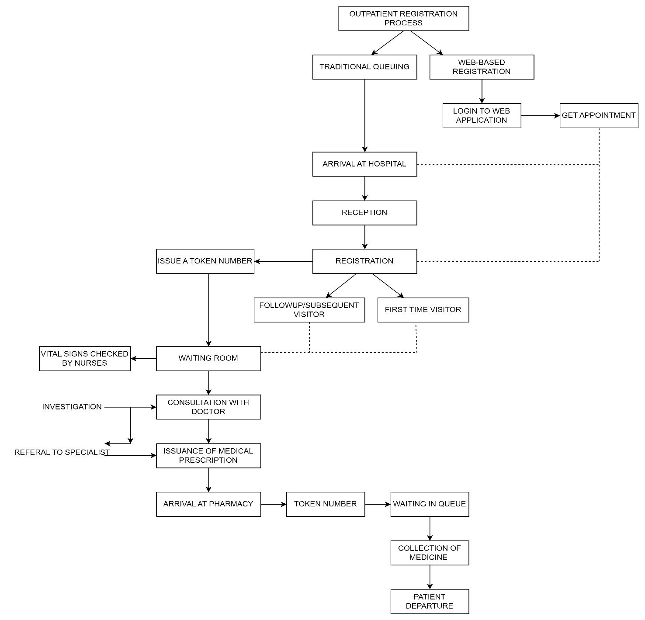

1. **Typical flow diagram for patients admitted to Emergency Department**

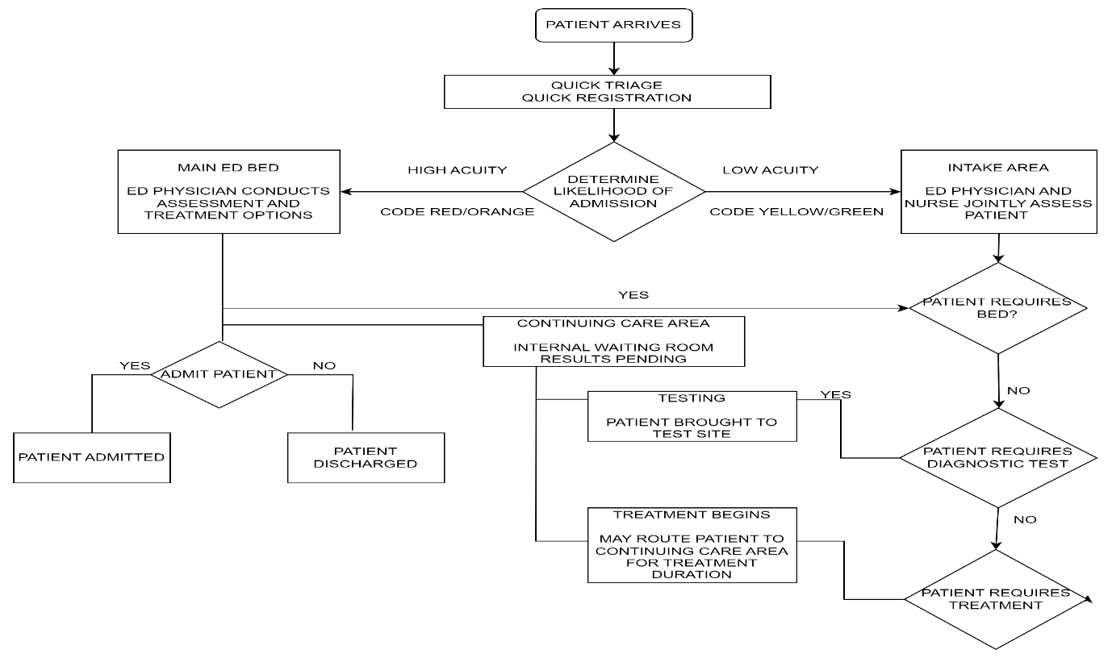

1. **Flow diagram for patients in Operation Theatre – Undergoing Surgical Procedure**

